Web URL

* Web Uniformed Resource Location (URL): uniquely identify the specific web resource inside the web application
* Every web application should have its unique
* address in the form of URL
* URL is one & only way to access web application via browser
* Max number of charterer in the URL is 200

**Syntax**

**protocal://<domainName>:port/resourcePath?queryString#fragementId**

EG :

<http://localhost:8888/index.php>

<http://google.com/search?q=iphone11>

<http://172.217.160.142/search?q=iphone11>

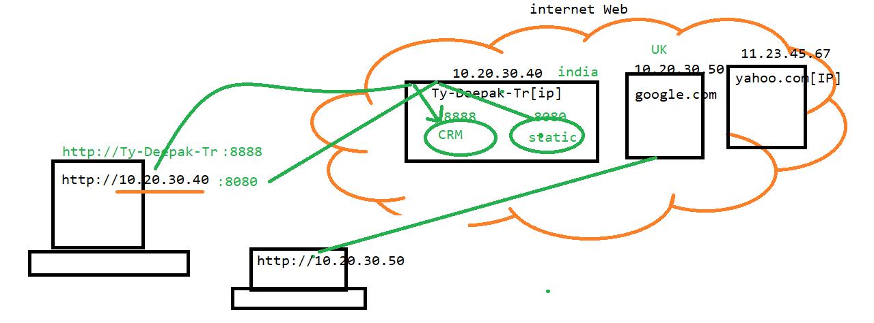

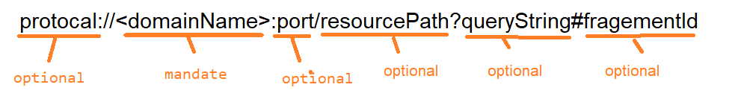

**Protocol**

* It’s a common language where two application exchange information each other
* When one application wants to communicate with each other (in our case browser & server), these need to be a common language which both application understand each other
* This language is known as protocol, where protocol as set of rules & instruction
* Browser always send a request & receive response via http protocol hence it is called http request / http response.
* It’s an optional information & case-insensitive
* Types of Protocol
  + http
  + https
  + ftp
  + smtp etc..

**Domain Name**

* Uniquely identify the specific computer in the network in which web application in present
* Domain name might be computer name or iP addresses
* It’s a mandatory information & case sensitive

Example:

[www.amazon.com](http://www.amazon.com/) (commercial)

.org (organization)

.edu (education)

.gov.in (governmen**t)**

**Port:**

* Uniquely identify the specific software/application inside the computer
* In the URL this is an optional information
* Below table specify the default port number

|  |  |  |  |
| --- | --- | --- | --- |
|  | **Tomcat** | **JBoss** | **WebLogic** |
| **http** | **8080** | **80** | **123** |
| **https** | **8443** | **443** | **456** |

**Resource Path:**

* Uniquely identify the specific web resource inside the application Server (web application)
* We know web application is a collection of web resources, so it’s a full path of web resource at web application side

**Example :**

[**http://localhost:8080/index.html**](http://localhost:8080/index.html)

[**http://localhost:8080/login**](http://localhost:8080/login)

**Fragment ID :**

* Identify the specific fragment / section in the webpage
* Its an optional information in the url